A STORY FROM THE LIFE OF MY GRANDMOTHER, REBECCA TURNER, AS I REMEMBER IT
By Millie Workman Erickson
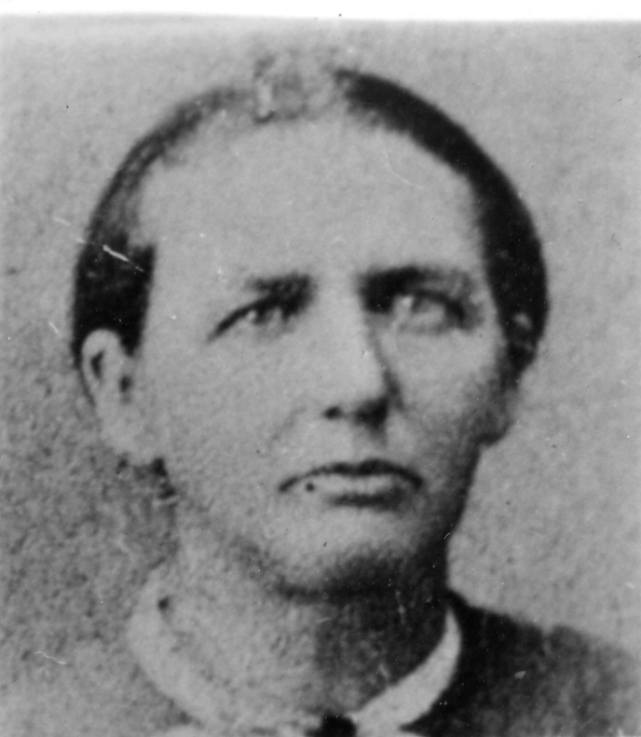
In the early days of the church as soon as one joined, they immediately wanted to go to Zion where the rest of the saints were. That is what happened to Rebecca's father and mother, Elizabeth and Nathaniel Turner.
Many years ago in the State of Maine, two strange men came to the Turner home one day and said they were Mormon missionaries. Elizabeth said, "Oh, come in, I have heard about you from a friend. I would like to have you come in and tell me about it." They went in and began to tell her all about the church--how an angel had appeared to Joseph Smith and told him if he would continue to live a pure life before the Lord that in due time he could bring forth the true Gospel of Jesus Christ, and he did. Elizabeth Turner believe every word they told her and she invited them to come back when her husband was home, so he could hear the message too. You see, Nathaniel Turner, or "Nate" as some folks called him, was a woodsman. He went about in the woods hunting what were called tree-knuckles. The natural bend in the tree was so strong that they were very valuable in building the hull of the ship before the use of steel for this purpose.
As Henry, the eldest son, grew older he liked to go with his father to the woods and soon became much help in the business. When they would find a "knuckle", Nathaniel would begin cutting and shaping it. Henry would scout about to find more "knuckles". He usually had one or more waiting for his father. Nathaniel declared he could not carry on the work without Henry. Henry being young and agile could get around through the woods and locate the knuckles in less time than his father.
One day when he was 10 or 12 years old, Henry had been extra active in the woods and had located several good knuckles for his father. That night when they got home, Henry was sick and could eat no supper. A very high fever developed rapidly. For days they worked and prayed over him. Then he began to get better. His right arm and leg was more or less affected with paralysis. That side did not grow like the other side any more, making him a cripple the rest of his days on the earth.
The Elders did come back when Nate was home and he was as interested in the message as was his wife, Elizabeth, so the Elders kept coming to their home until it became quite a gathering place.
The time came for them to be baptized so they sent word to her father and mother to come and join them. Elizabeth's parents did come and they were determined to stop them from being baptized. They said it was nonsense and they could not do it. They thought it was unbelievable that Nate and Elizabeth would want to belong to those "awful Mormons". Elizabeth was firm in her belief and joined the Mormon Church in spite of her family's protests. Not long after their neighbors found out, they began to avoid meeting them or even speaking to them when they did meet.
Once members of the Church, the spirit of emigration seized them. They wanted to be with people of that faith that they might enjoy fellowship with them and the blessings of the Priesthood. They started the long arduous journey from the East coast of Maine to Nauvoo, Illinois. Besides their son Henry, they had a girl named Rebecca and a baby named David. They endured many hardships but they would not turn back. After many days they arrived in Nauvoo. They were happy to meet other members of the Church. One of the former missionaries who loved them dearly helped to get them established. All went well for a few weeks, but there was a lot of sickness in the city, a disease called the "black tongue". The little family was quite run down in health, because of their long journey and the lack of proper food. The mother contracted the disease, was sick about a week, then died. What a terrible blow it was to the little family to have their precious mother taken away from them. That left the father and his three little children. In about two weeks, the father contracted the same disease and died leaving the three little children alone.
The Saints felt sorry for the children and took care of them as best they could, but they themselves had about all they could stand without taking these little orphan children. Word was sent back to Elizabeth's parents that she and her husband were both dead and the children were left alone. Elizabeth's brother, Samuel, started for Nauvoo to bring the orphaned children home to their parent's people but Samuel sickened and died on the way without reaching the Mormon City. Two years later another brother, William Barter, started for Nauvoo. He also sickened and died on the way over that wild and unknown country. In their determination to get the orphan children, Elizabeth's youngest brother, Cyrus Barter, left his wife and family and started on the journey. The same fate struck him. It seemed those children were not supposed to return to the people who despised the Mormons, but were to remain with the people of the same faith as their parents to be reared under the light of the Gospel of Jesus Christ.
A Mr. Covey said he would take Rebecca. She was about 9 years old, a sweet child and a good worker. She could help Mrs. Covey with the children. A family by the name of Lambert decided to take young David Sevy who was 7 years old. But Henry being a cripple, about 12 or 13 years old, worked around wherever he could get a job to pay his way. Henry felt so lonely for his little brother and sister, he would go every chance he got to see them and stay as long as he could. The three children loved each other dearly and wanted to be together. Henry said he wished he was older so he could take care of them himself and they could be together.
Finally the time came they were to be separated. The Coveys were going with a company to Utah. This made Henry very sad, and Rebecca herself hated to go without her brothers. The day of parting came. The Coveys were to leave in the morning. Henry spent much of the night telling her to be a good girl and always be true to the Church. He did so wish he could go with her to Utah, but his leg bothered him so much he could not walk, and no one had room for him to ride.
Early the next morning, Henry came down to help Rebecca get the cows started and walk a way with her. He went about a quarter of a mile. She knew he must not go further, as it would be too difficult for him to walk back. The parting was sad, they both cried on each other's shoulders, then said good-bye. Rebecca kept looking back. She watched her brother limping along the road until he appeared as just a speck in the distance. Never did the picture leave. It was carried in her eyes and her heart.
There was a boy named John who was driving cattle for another family. They let his mother ride in their wagon if he would drive their cows. Rebecca had wished the Coveys had let Henry ride for her driving their cattle. John was 11 years of age, about the same as her brother, Henry. Rebecca and John became very good friends. At night when they camped she would go over to John's wagon and visit with his mother. The mother loved Rebecca as her own daughter. This love continued even more when they reached the Salt Lake Valley.
Later the Lamberts came west, but went on to California. David was well and getting along fine with his new parents. Rebecca's great longing was to see Henry come to Utah.
Several years passed, Rebecca spent her leisure time with John and his mother. John was now 16 and Rebecca was 14. One night when John came home from the field his mother was ill with a fever. The fever continued to go higher and higher. John got the doctor and he said, "Your mother has pneumonia, and I fear for her life." John immediately went for Rebecca. She came with him and together they watched by the mother's bedside all night. They did not leave her bedside the next day, but did all they could to follow the doctor's directions. Her final hour came and she passed away without recognizing them. Rebecca and John felt alone in the world. They grieved very much.
After she was laid to rest, her son said, "Rebecca, we are too young to marry, and anyway I am not in a position to take that step. I have no way of taking care of you. I have decided to go to California and seek my fortune. Who knows, I might strike it rich. If I do, I'm coming back and we'll build a home together. You take all of mother's belongings, her feather bed and pillows, etc., and keep them as your own." With that he was gone. For two years she waited and prayed for his return. but not one word came from him. She thought he must have died in the desert country. Everything sweet and dear in life seemed to have been taken away from her.
Now in the Salt Lake Valley, the saints were practicing polygamy. Pres. Brigham Young told the good men to take another wife. A man named Jacob Workman had lost his wife in Mt. Pisgah. He had married a widow woman who was taking care of his children. When Brigham Young told him to take another wife, he thought of Rebecca. He knew she was a good girl and had no folks of her own. He decided to ask her to marry him. Several times he called to see her and finally he asked her to be his wife. She hesitated at first, but when he promised to send for her brother Henry who was still in Nauvoo, she consented. They were married on the 3rd of January 1852.
When spring came, a company was organized to go back for more Saints. Jacob Workman provided a wagon and a pair of oxen if they would bring Henry Turner back. Rebecca sent a letter to Henry telling him how glad she would be to have him come to Utah. She waited and waited for the wagon train to come. Finally word came that the wagon train would arrive that day. As the wagons pulled into the yard, her heart leaped for joy at the thought of seeing him again after so many years. Jacob Workman spied his oxen and wagon. They hurried over to it, but the man said, "Your brother is dead. He had been ill for some time, and when the news came that he at last could come to Utah, he could not stand the excitement and his heart stopped beating." Again poor Rebecca was to endure heart break.
They returned to their home and her only comfort was her own dear baby boy. One day she took him over to show Mrs. Covey. She asked her, "Did you see John?" "He came back for you, and when I told him you were married he said, "Oh, dear, I am too late." The neighbors said he looked through the window and saw her with the baby. They told him to go on in the house, but he said he would not make her unhappy again. He went on his way without seeing her and was never heard of again.
This little woman raised 11 children to adulthood. They in turn had families and her posterity is numerous. Neither Henry, the crippled boy, nor her brother David had any children.

